INTERNSHIP DAY-03 REPORT

Git & GitHub + Postman + APIs
Practiced the full Git/GitHub workflow and contributed a real fix to an open-source n8n project via fork → branch → PR, then built and tested a four-endpoint Lead Management API (Create/Get/Update/Delete) in n8n, backed by Google Sheets and verified end-to-end with a Postman collection

Submitted to: Mr. Muhammad Ahmed Tahir
(CEO and Founder MATalogics)

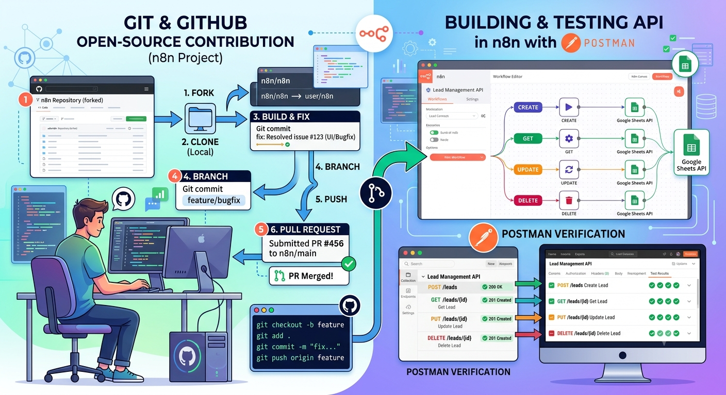
Date: 8 August, 2026

Module 1 — Git & GitHub

Task 1: GitHub Setup
Git was installed and configured locally with the required identity:
· git config --global user.name "Anila Gulzar Toor"
· git config --global user.email "anila.toor@gmail.com"
· git init — initialized the local repository
Core Git commands practiced in the terminal:
· git clone <repository-url> — used to clone the open-source repository (Task 3) and the fork
· git add . — staged changes before committing
· git commit -m "Completed Day 3 Assignment" — recorded snapshots with meaningful messages
· git push — pushed local commits to the remote (fork on GitHub)
· git pull — synced local branches with the remote

Task 2: Internship Repository
A public repository named AI-Automation-Internship was set up locally, structured with a root README.md and a Day-03/ folder containing five sub-folders: GitHub, Postman, n8n, Google Sheets, and Report — matching the required deliverable layout exactly.

Task 3: Explore & Contribute to an Open-Source Project
Topic chosen: n8n (workflow automation) — directly relevant to the Lead Management API built later in this task.
Item | Detail
Original repository | https://github.com/enescingoz/awesome-n8n-templates
Forked to | https://github.com/anilatoor/awesome-n8n-templates
Improvement made | Fixed nine broken “Link to Template” entries in README.md caused by unescaped parentheses in filenames (Markdown link syntax truncates at the first unmatched “)”), plus a hardcoded absolute link that broke when viewed from a fork. Committed on a feature branch (feature/my-improvement) and pushed to the fork.
Pull Request | https://github.com/enescingoz/awesome-n8n-templates/pull/178 — Pull Request open, awaiting maintainer review (submitted August 8, 2026).

Git commands used for the contribution workflow:
· git clone <repository-url>
· git checkout -b feature/my-improvement
· git add .
· git commit -m "Improve documentation and add workflow example"
· git push origin feature/my-improvement
Evidence:
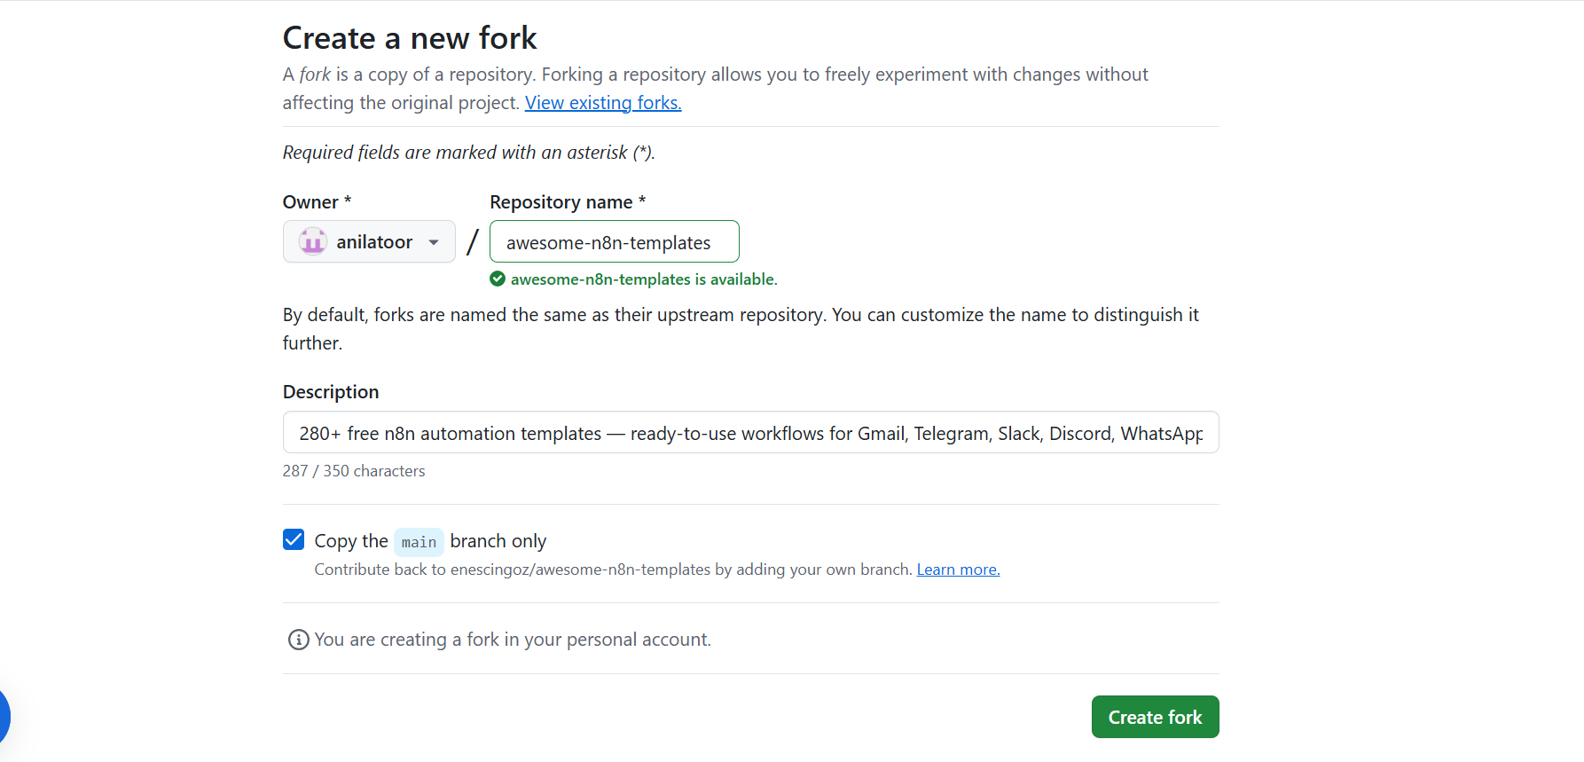
Creating the fork on GitHub
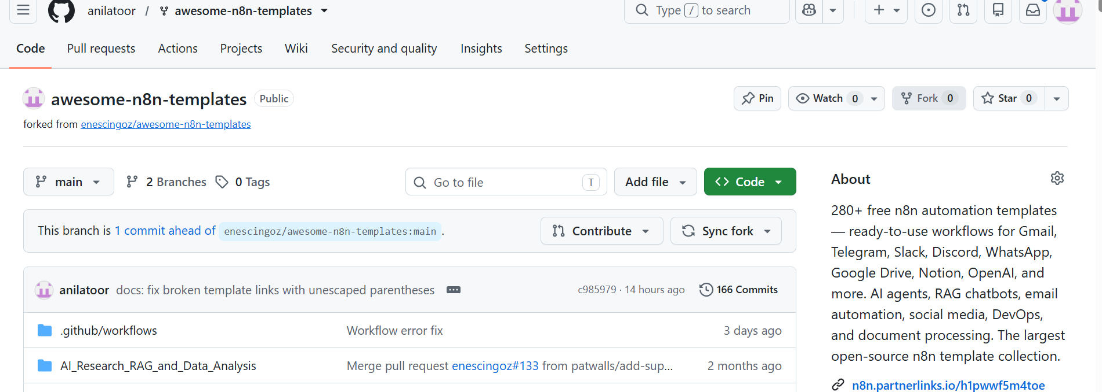
The forked repository under the personal account
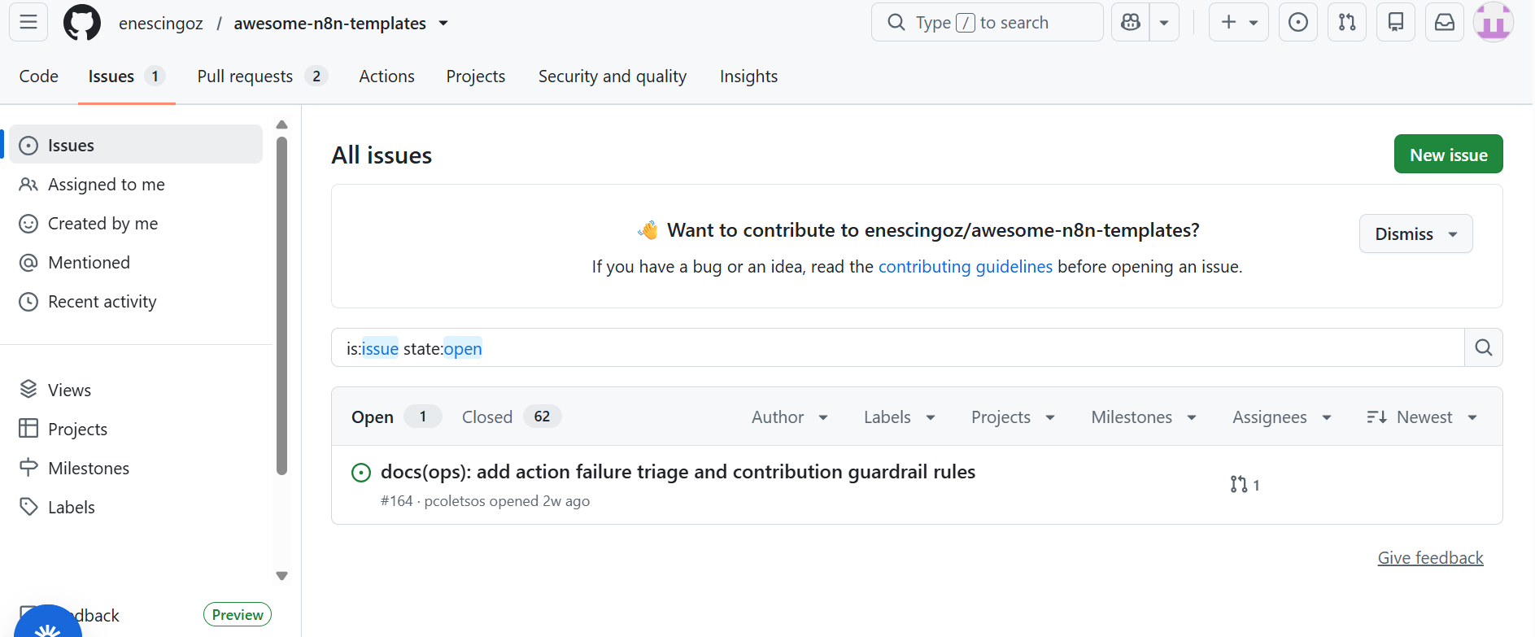
Issues and Pull Requests view on the repository
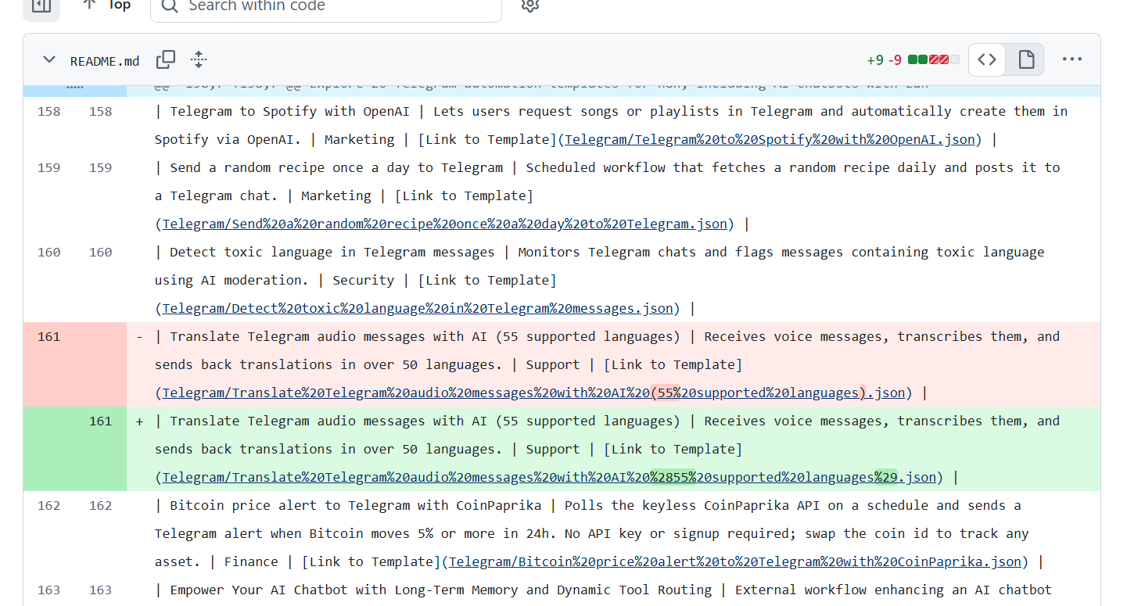
Contribution to the repository
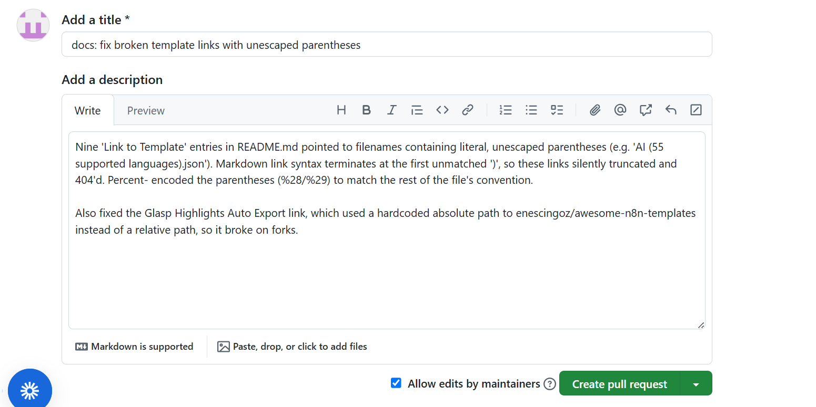
Creating pull request

Module 2 — API Fundamentals

What is an API?
An API (Application Programming Interface) is a defined contract that lets two pieces of software communicate one side (the client) sends a request in an agreed format, and the other side (the server) processes it and returns a response. In this project, Postman acts as the client and the n8n webhook endpoints act as the server, exchanging JSON over HTTP.

REST API
REST (Representational State Transfer) is an architectural style for APIs where each resource (e.g. a "lead") is addressed by a URL, and standard HTTP methods describe the action to perform on it. The client sends a stateless HTTP request; the server looks up or modifies the resource (here, a row in Google Sheets) and returns a status code plus a JSON body describing the result.

HTTP Methods
Method | Example in this project
GET | GET /get-leads — retrieves every lead row from the Google Sheet, no request body needed.
POST | POST /create-lead — creates a new lead by appending a row, with a JSON body (name, email, phone, company, interest).
PUT | PUT /update-lead — updates an existing lead's details by matching on email and overwriting the row.
DELETE | DELETE /delete-lead — removes a lead's row by looking it up by email and deleting it.

HTTP Status Codes
Code | Meaning
200 (OK) | Request succeeded (used for Get Leads, Update Lead, Delete Lead responses).
201 (Created) | A new resource was created (used for the Create Lead success response).
400 (Bad Request) | The client sent invalid data (used when name/email validation fails on Create Lead).
401 (Unauthorized) | Missing or invalid authentication credentials.
404 (Not Found) | The requested resource/endpoint does not exist.
500 (Internal Server Error) | The server failed while processing an otherwise valid request.

Headers
- Content-Type: tells the server the format of the request body, e.g. application/json.
- Authorization: carries credentials such as a Bearer token to authenticate the request.
- Accept: tells the server what response format the client expects back.

Authentication
- API Keys: a static secret sent with each request (e.g. in a header or query param) to identify the caller.
- Bearer Tokens: a token sent in the Authorization header (Authorization: Bearer <token>) proving the caller already authenticated; used as the auth type configured on each request in the Postman collection.

Module 3 — Postman, n8n & Google Sheets

Postman Practice
A Postman workspace and collection were used to practice the fundamentals before building the Lead Management API collection:
- GET Request: sending a basic GET and inspecting the response
- POST Request: sending a JSON body with a POST request
- Variables: using collection/environment variables instead of hardcoded URLs
- Authorization: configuring Bearer token auth on requests
- Export Collection: exporting the collection as a .postman_collection.json file
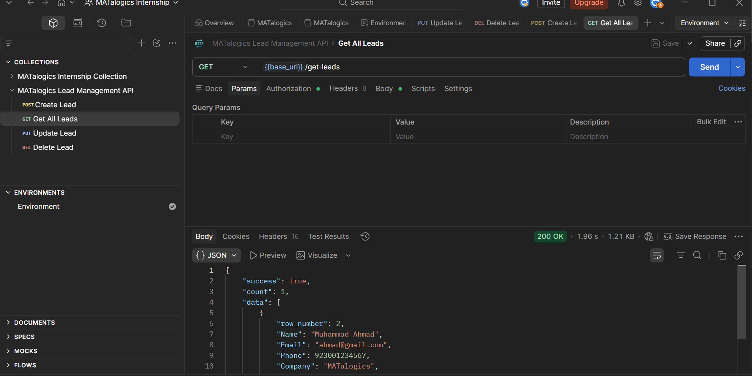
Postman GET request
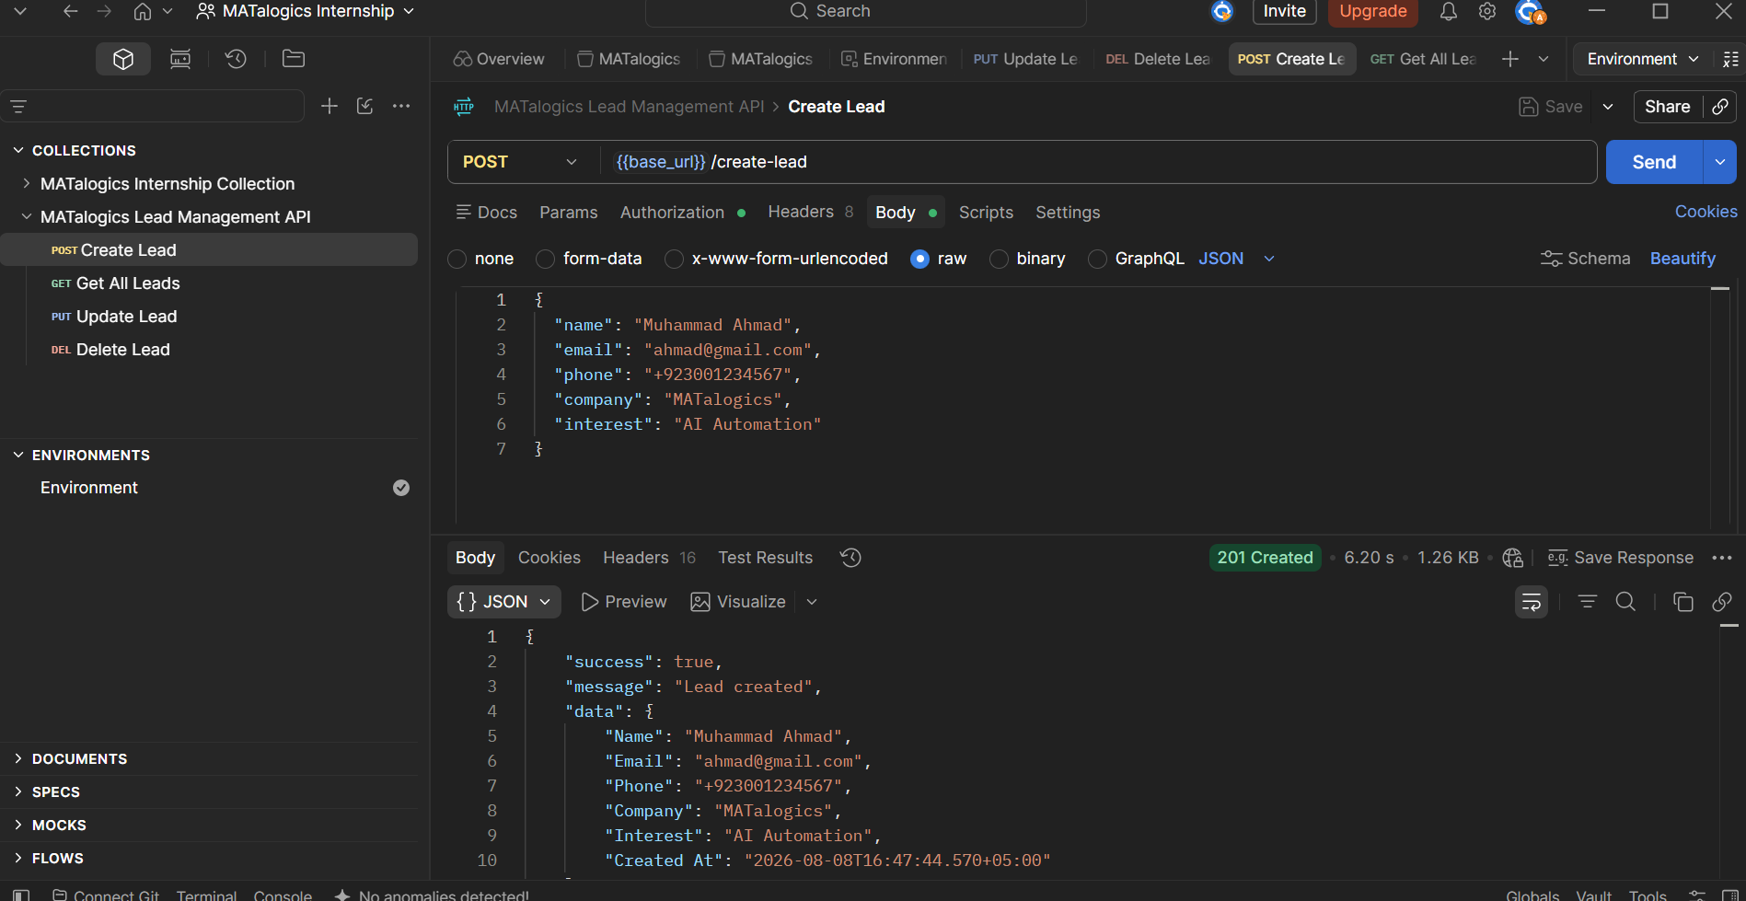
Postman POST request
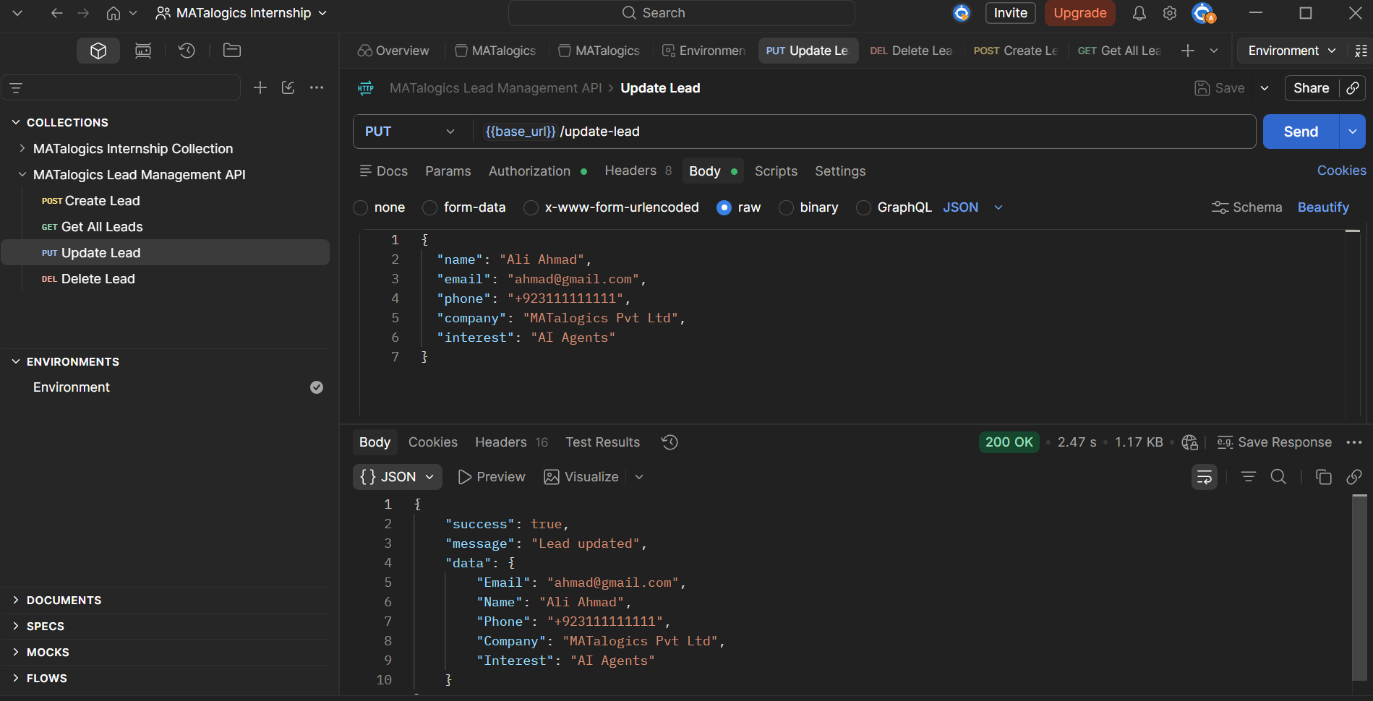
Postman PUT request
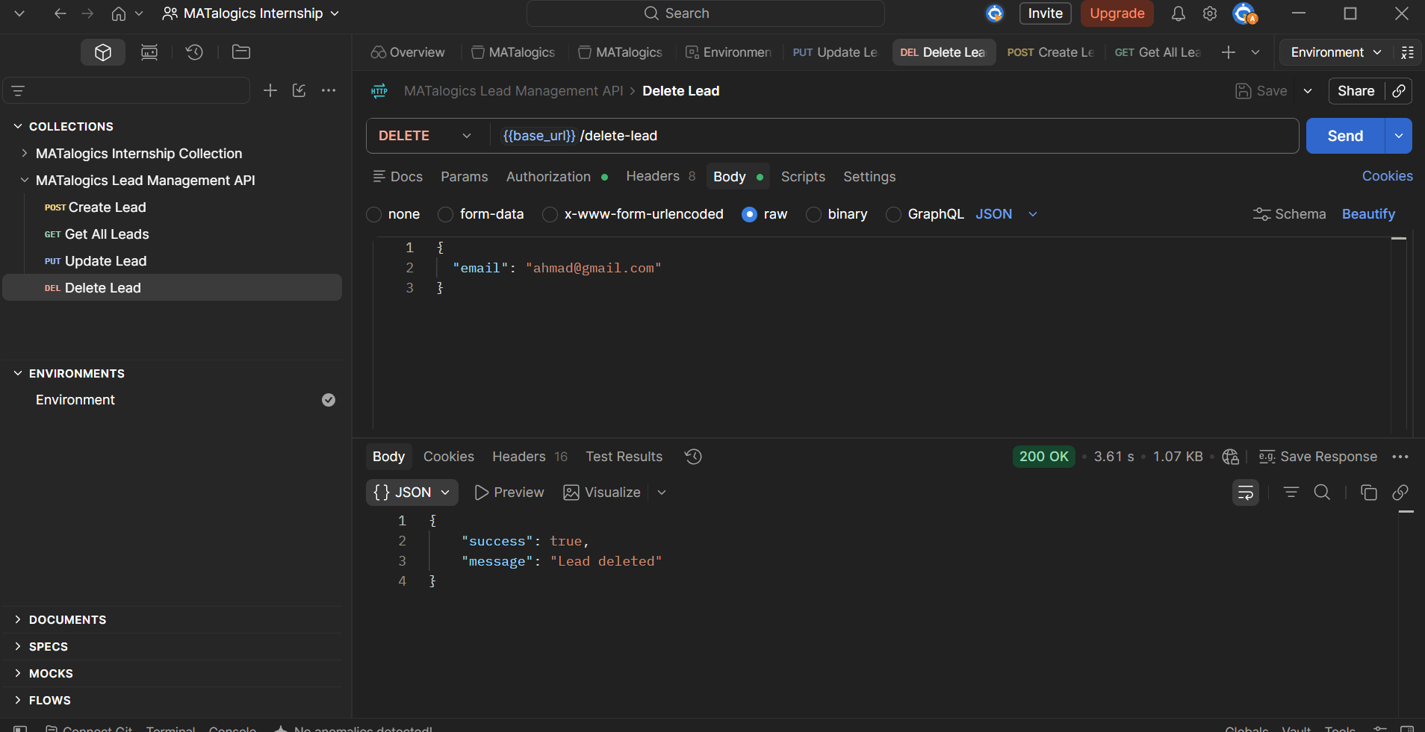
Postman DELETE request

APIs Implemented — Lead Management API
A single n8n workflow ("Lead Management API") hosts four webhook endpoints, all reading from and writing to one Google Sheet named "Lead Management".
Endpoint | Method | Purpose
/create-lead | POST | Validates name & email, appends a new row to Google Sheets, responds 201 with the created lead (400 on validation failure).
/get-leads | GET | Reads all rows from Google Sheets and responds 200 with the full list of leads.
/update-lead | PUT | Finds the row matching the given email and overwrites phone, company and interest, responds 200.
/delete-lead | DELETE | Finds the row matching the given email and deletes it, responds 200.

Postman Collection — MATalogics Lead Management API
The collection includes all four requests (Create Lead, Get All Leads, Update Lead, Delete Lead), each using the {{base_url}} variable and a JSON request body, with Bearer auth configured per request.

Workflow Overview — n8n
All four sub-workflows live inside one n8n workflow, each starting from its own Webhook trigger node:
- Create Lead: Webhook (POST) → Normalize Input → Validate Data (IF) → [valid] Google Sheets Append Row → Respond 201 Created | [invalid] Respond 400 Validation Error
- Get All Leads: Webhook (GET) → Google Sheets Read Rows → Respond 200 with all records
- Update Lead: Webhook (PUT) → Normalize Input → Google Sheets Update Row (matched by Email) → Respond 200 Updated
- Delete Lead: Webhook (DELETE) → Normalize Input → Google Sheets Find Row (by Email) → Google Sheets Delete Row → Respond 200 Deleted
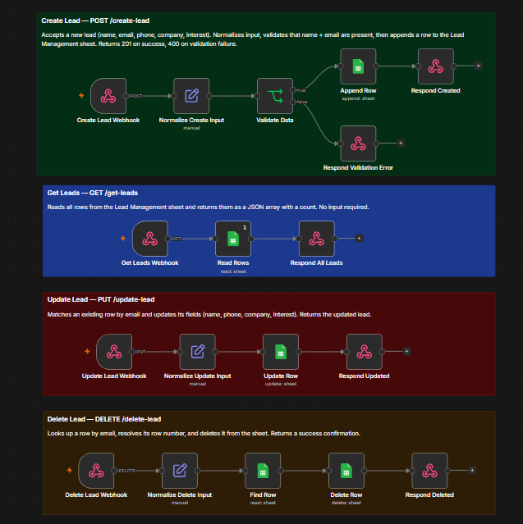
n8n workflow canvas

Google Sheets — Lead Management
Sheet columns: Name | Email | Phone | Company | Interest | Created At
Matching the schema used by every Google Sheets node in the workflow.
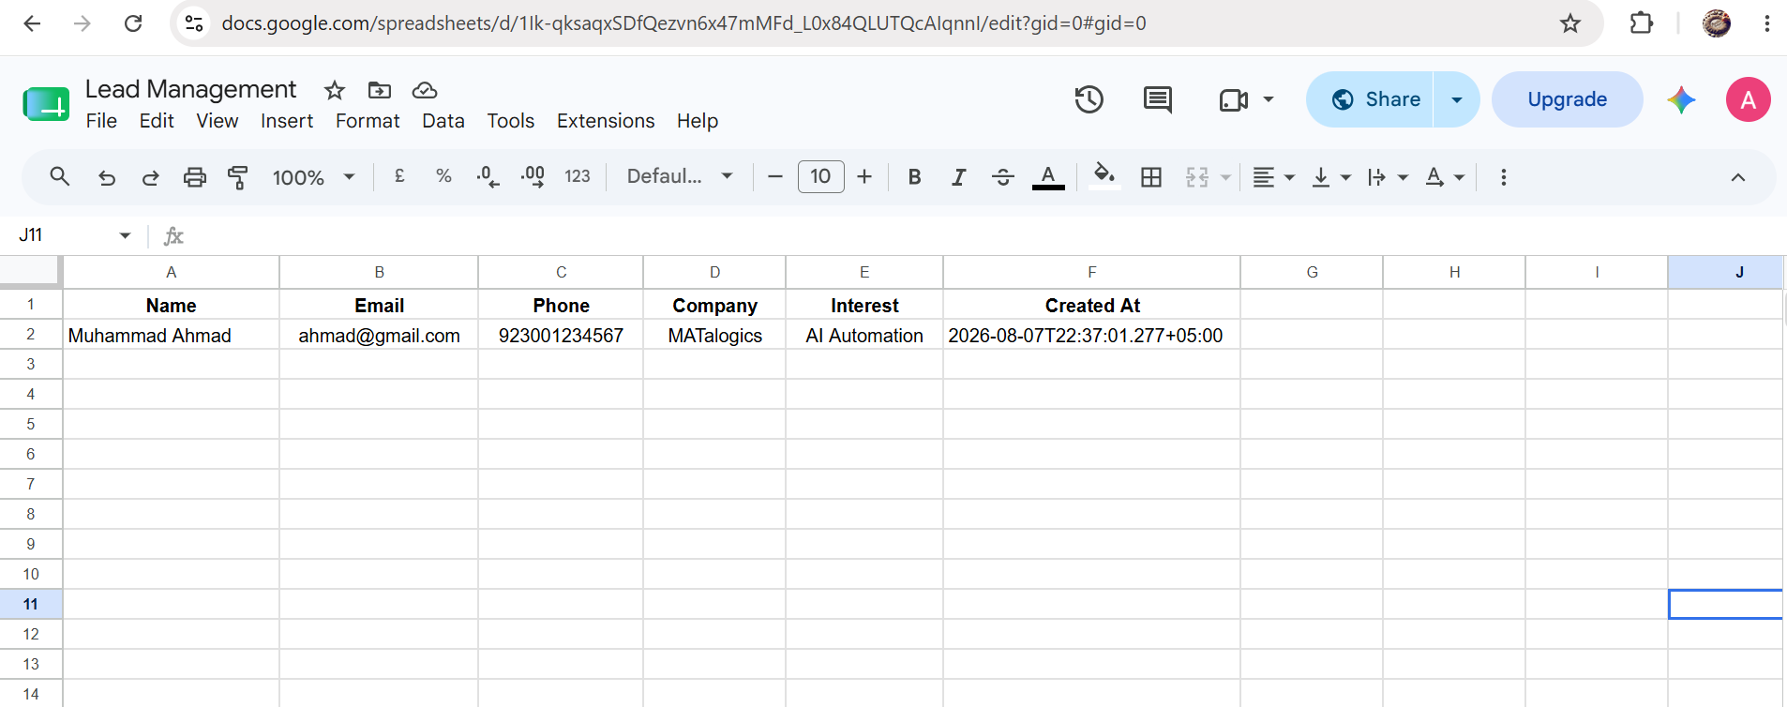
New lead row appended after a Create Lead request
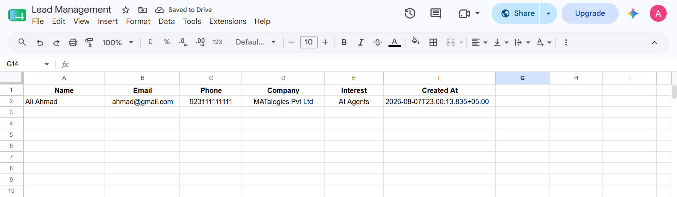
Lead row updated after an Update Lead request
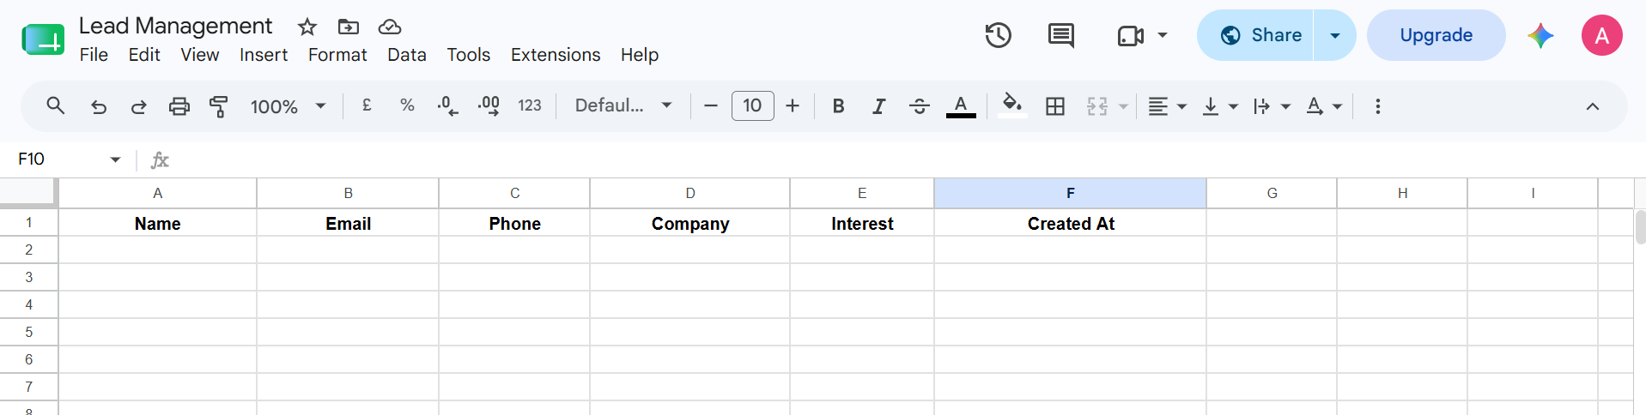
Lead row removed after a Delete Lead request

Learning Outcomes
- Practiced the core Git workflow (init, clone, add, commit, push, pull) and branch-based contribution (checkout -b, push to a feature branch) on a real open-source project.
- Learned how forking, cloning and Pull Requests fit together as the standard open-source contribution cycle.
- Understood REST API concepts in practice, mapping CRUD operations (Create/Read/Update/Delete) onto HTTP methods (POST/GET/PUT/DELETE) and reading HTTP status codes to confirm success or diagnose failure.
- Built and tested a real multi-endpoint API using Postman - collections, variables, JSON bodies, and Bearer authentication, rather than just reading about it.
- Learned to design an n8n workflow that exposes multiple webhook endpoints inside a single workflow, each validating input before writing to an external data store.
- Used Google Sheets as a lightweight, inspectable database for a working automation, wiring the same sheet into four different operations (append, read, update-by-match, delete-by-match).
- Understood how the pieces connect end-to-end: a Postman request → an n8n webhook → a Google Sheets operation → a JSON response back to the client, the same request/response chain that powers real production automations.

